**Terms and Conditions**

**Feasibility Studies (2021)**

**Programme objectives and scope**

The “feasibility studies” funding supports projects that aim to verify the technical feasibility of an innovation with significant technical challenges. The innovation whose feasibility is verified must represent an important step in relation to the state of the art in the industrial segment covered by the project. Therefore, the programme does not cover the study of the feasibility of minor technical developments.

The aim of the feasibility study is to verify the technical feasibility of innovations with a level of technological maturity ranging from TRL3 to TRL5 on the scale of technological maturity of an innovation[1] (see scale below). More specifically, the feasibility study defines the main characteristics and parameters of the innovation, clarifies the constraints and requirements of the development phase, and enables a company to make the technical choices necessary for the realisation of the innovation.

The scope of the feasibility study starts after the theoretical validation of the innovation and ends with the finalisation of a Proof of Concept (PoC) (TRL5). The scope of this programme does not include the development of a prototype of the innovation. However, the development of a prototype falls within the scope of Innoviris' [R&D project funding](https://innoviris.brussels/rd-projects)

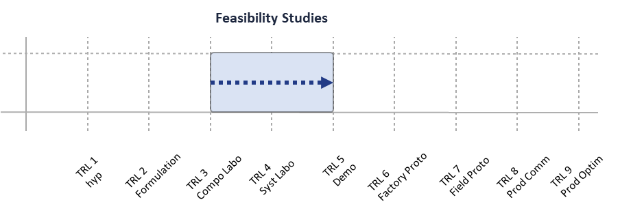

*How are projects funded?*

Projects are financed in the form of subsidies according to the size of the company in the table below.

|  |  |
| --- | --- |
| **Company size** | **Level of contribution individual project subsidy** |
| Micro enterprise | 70% |
| Medium-sized enterprise | 60% |
| Large enterprise | 50% |

.

**Eligible costs**

Eligible costs are as follows:

* **Staff costs:** personnel costs (salaried or self-employed) to the extent that they are employed on the project. Wages must be in accordance with the practices and salary scales (if any) of the industry in question.
* **Investment costs:** costs of instruments and equipment used in the project (purchase cost/depreciation period*project usage period*usage rate).
* **Subcontracting costs:** This category relates mainly to subcontracting in the broad sense. The company can, if necessary, call upon relevant external expertise (such as services provided by a Fablab).
* **Operating costs:** including the costs of materials, supplies and products, necessary for the successful completion of the project.

A more detailed description of eligible expenses is available in [Innoviris' accounting guidelines](https://innoviris.brussels/documents/general-accounting-directives-2021).

|  |
| --- |
| **Note – Explanation of the ability of the company to contribute its financial share** |
| In addition to being able to secure its financial share of the project, it is important to note that any applicant organization must be financially prepared to advance the costs necessary to carry out the project, given that there may be a time lag between the start date of the project and the receipt of the first instalment of the subsidy, and that the payment of a portion of the subsidy is always made after the project is completed. |

**Eligibility criteria**

In order to benefit from the financial intervention of the Brussels-Capital Region (BCR) in the framework of this program, each applicant must

* **Be a company**: any company with a legal entity of any form (SA, ASBL, SC, SRL, etc.) at the closing date of the call is eligible.
* **To have at least one operating headquarter in the BCR**.
* **To not be in financial difficulty**: see section 20 of the Guidelines on State aid for rescuing and restructuring firms in difficulty other than financial institutions. This aspect only concerns companies that have been in existence for more than three years.
* **Propose a project that corresponds to the scope of the action**: the project must meet the objectives of the program.
* **Have fulfilled any obligations towards the Region in the context of previous aid**.
* **Demonstrate the incentive effect of the aid**: the applicant company must demonstrate that the project could not be carried out, or would have to be significantly less ambitious, without the intervention of Innoviris.
* **Not already benefit from public support for the tasks included in the project** (prohibition of double financing).

**Selection/evaluation of applications**

Applications for funding are received followed by the verification of eligibility. Eligible applicants will then be invited to defend their project at a review meeting.

At the review meeting, applicants will have the opportunity to present their project, followed by a question-and-answer session, at the end of which a funding decision will be made. For projects classified in the "Industrial Research" category, an expert jury will also be organised to evaluate the scientific aspects of the project

As the decision on whether or not to recommend for funding is made at the end of the review meeting, it is crucial that the information provided in the application form is complete, detailed and substantiated. It is important to note that the following aspects will be evaluated:

* **Innovation and project objectives:** the project following the feasibility study must represent an innovation at the global level and a significant step forward from the state of the art in the industrial segment covered by the project.
* **Feasibility and implementation:** The work program must be relevant and realistic in terms of tasks, budget, expertise, and resources.
* **Economic and strategic impact:** The activity under consideration must demonstrate a real potential for value creation. The underlying assumptions are translated into figures in a financial plan and demonstrate the economic sustainability of the activity studied. The project must be in line with the organization's overall strategy and reflect a viable business model.
* **Societal impact:** the activity that is the subject of the project must demonstrate a social, environmental and/or Brussels ecosystem impact.

1. <https://www.wsl.be/matmax/home_d.php?lang=en>