RULES

PROOF OF BUSINESS

# Contexte général

At a time when many innovative technology start-ups are investing a great deal of time and resources in R&D, some companies frequently find it difficult to reconcile their technological challenges/choices with the real expectations/needs of the market, due to a lack of validation/testing of a validly developed business and operational strategy prior to building a portfolio of their own products/services, or as a result of too many ineffective strategic pivots that are costly in terms of time, money and energy.

With this in mind, Innoviris is using this form to offer support for a proof of business (POB) phase for Brussels-based technology companies aiming to bring their first innovative product/service to market.

# Objective and philosophy

The main challenge of this funding program is to demonstrate the business and strategic relevance of the development of a **first innovative product/service**, as well as the correspondence between these operational concerns and the technological choices and challenges still to be made before the development of the product/service itself, with a view to long-term growth and sustainability. Thus, for one (or more) specific needs previously identified in the market, the program aims to test the relevance of a formulated value proposition through the validation/validation of pre-established working hypotheses. In addition, it also tests the credibility of the technological choices to be made for the development of a technologically innovative product or service that answers this need.

Specifically, this support takes the form of a non-refundable grant of 50-70% (depending on the actual size of the company, and with a maximum intervention of 70,000 euros) of the budget, which the applicant company must justify. This budget is to cover the expenses of the POB demonstration, regardless of the activity sector involved (ICT, health, environment, chemistry/biotechnology, etc.

The work program proposed under this program **should** include the tasks related to the demonstration of a proof of business (POB), possibly complemented by one or more minor technical modifications of the proof of concept (POC) resulting from the test phase conducted under the POB (see CRL/TRL matrix below).

The proposed work program should last at least 6 months, but not more than 12 months.

# Positioning the POB tool on the CRL/TRL scale1

The CRL/TRL scale is a matrix designed as a working tool for the innovative entrepreneur to measure the level of readiness of an innovation project according to two dimensions:

* **The technical readiness level (TRL)**
* **The commercial readiness level (CRL)**

The POB tool proposed by Innoviris occupies the following position on this matrix:

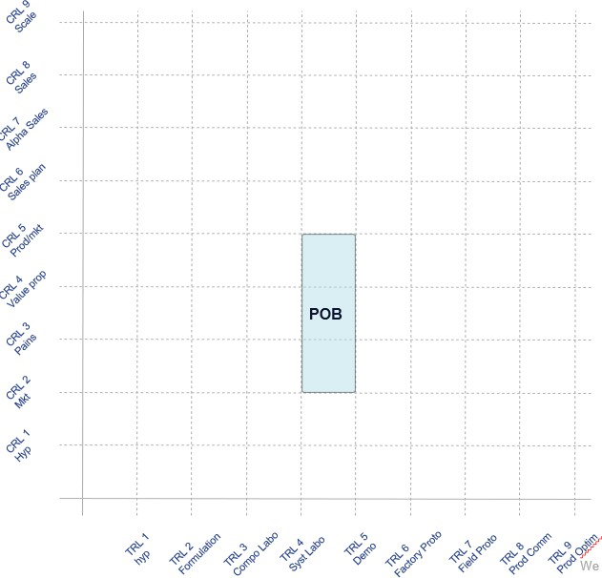

Technically, a company applying for the POB program must have at least the following:

* at level TRL 4 - Experimental/POC in lab:
  + the various basic components of the solution were pre-assembled into a system that operates with 'low reliability' (pre-established POC);
  + the operation of this system was validated at the experimental level and its basic performance was measured in a test environment;
* at level CRL 2 - Market Analysis:
  + you have already acquired a good understanding of the market structure and segmentation;
  + you have estimated the size and growth of this market;
  + you have mapped the ecosystems; the parties involved, the potential partners and the competitors;.
  + you have determined the value chain of the market and the company's intended position in that chain;

1 CRL: Commercial Readiness Level – TRL: Technology Readiness Level, as defined in the MatMax-matrix of WLS: <https://www.wsl.be/matmax/home_d.php>

* + you have selected one or a small number of segments (<= 3) as potential commercial target groups;.
  + you have drawn up a list of customers you want to reach in the following phases.

As indicated by the arrow in the matrix above, Innoviris' POB program aims to enable the company using this tool to reach the TRL5 and CRL5 levels (no higher), i.e.:

* TRL5 : in a simulated environment.
  + the components have been realistically integrated into a functional (laboratory) system, particularly through the definition and implementation of documented interfaces between the components;
  + the functions and performance of the system have been validated in a real application and in a (simulated) environment representative of the final environment;
  + a functional 'specification' of the product was prepared based on market demand;
  + the expected architecture of the final product could be defined and documented;
* CRL5 : validation of the product-market combination.
  + based on the validated market needs and value proposition, you selected the intended target segments and defined the MVP (minimum viable product) specifications;
  + you have verified that the MVP meets the key needs of the customers in the target segment;
  + you have verified that the value as perceived by the customer can actually be generated in the form of revenue;
  + you have quantified the revenue and cost estimates and verified that a profitable business model exists.

# Accepted tasks and assignments

The following tasks may be the subject of a Proof Of Business funding application: they serve to test the correspondence between the technological choices and challenges to be made prior to the development of the innovative products/services under consideration and the relevance of the value proposition/business model to be applied to meet the expectations of the target market:

* validation trials;
* on-site demonstration and presentation of the company's POC to customers by way of testing;
* introduction of reservations and analysis of user feedback, with a view to better positioning the functions to be developed and their potential operational and financial impact;
* testing and prevalidation of the price;
* testing of the intended technical and business positioning with respect to the strategy followed by the pioneers of the activity sector in question;
* etc.

In general, the technical and business tasks related to the POB that can take the company from a TRL4/CRL2 combination to a TRL5/CRL5 combination are potentially allowed.

The applicant may also subcontract some tasks, if necessary, provided that the technical and business risks associated with the proposed work program are primarily borne by the company implementing the POB project, or that a plan is clearly established and submitted for the internalization (during or at the end of the POB project) of any missing skills that are critical to the implementation of the project.

**The following tasks are de facto excluded:** macro-level market research and statistical research, determination of the general market need related to the product/service being developed and general determination of the business model to be set up, commissioning, protection of intellectual rights, ongoing management expenses, etc.

# Eligible costs

The following costs are eligible:

* **personnel costs:** : the costs associated with staff (employee or self-employed) to the extent that they are assigned to the project. Remuneration should be in line with the practices and scales (if applicable) of the activity sector concerned;
* **investment costs :** costs of instruments and equipment used during the project (acquisition cost/depreciation period*use period during the project*use percentage);
* **subcontracting costs:** this mainly concerns subcontracting in the broad sense of the term. The company can, if necessary, call on relevant external expertise (such as services provided by a Fablab);
* **operating costs :** : in particular, the costs of materials, supplies and products required for the proper
* execution of the project.

A more detailed description of eligible costs is available in the accounting guidelines from Innoviris.

|  |
| --- |
| **Note - Availability of own funds** |
| It is important to bear in mind that any applicant organization must be financially capable of advancing the implementation costs of the project. Indeed, there may always be a time lag between the disbursement of the first grant instalment and the project start date. In addition, a portion of the grant will not be paid until after the project is completed. |

# Eligibility Requirements

To be eligible for financial support from the BCR under this program, the applicant must:

* + Pursue as an underlying goal for its "PROOF OF BUSINESS" application the development of an initial technologically innovative product/service (not an existing product/service portfolio. Switching from a product-oriented to a service-oriented business model and vice versa is also excluded);
  + demonstrate that it is truly rooted in Brussels;
  + demonstrate the beneficial impact of the project in the BCR (economic, employment, environmental, social/societal effects, generation of know-how and skills, intellectual property, well-being of employees/citizens, or any other positive external factor that may demonstrate the exemplary role of the project manager in the field of the economic transition supported by the region);
  + justify the incentive effect of the support on the implementation of the proposed work program;
  + Have fulfilled obligations within the framework of subsidies previously granted by the Brussels Capital Region;
  + have established the business no later than the date of submission of this completed application form.

# Selection/evaluation of the applications

Applications are assessed on the basis of their eligibility and fit with the general philosophy of the POB programme, as well as through an oral pitch by the team responsible for carrying out the work programme to the Innoviris advisors in charge of evaluation, followed by a question and answer session, at the end of which a decision is taken on whether or not to fund the project.

It is important to note that the following aspects will be assessed:

* + **Innovation and project objectives**: The project objectives must be clear and concrete. In addition, the project must make significant advances in relation to the state of the art in the field concerned or to what is being done by pioneers in the sector, as well as demonstrating the existence of technical challenges.
  + **Feasibility and implementation**: the work programme must be relevant and realistic in terms of tasks, budget, expertise and resources.
  + **Strategic and economic impact**: the activity covered by the project must demonstrate real potential for creating value. The underlying assumptions must be set out in figures in a financial plan, demonstrating the economic sustainability of the activity studied. The project must be in line with the organisation's overall strategy and reflect a viable business model.
  + **Value and impact**: the activity covered by the project must demonstrate a social, environmental and/or ecosystem impact in Brussels.

**It is crucial that the information provided in this form is complete, detailed and substantiated.**

Finally, it should be noted that this aid cannot be combined with the funding programme for feasibility studies made available by Innoviris.