Digital communication kit

Website news incl. link Innovative Starter Event
NL https://innoviris.brussels/nl/news/innovative-starters-award-back
FR https://innoviris.brussels/fr/news/innovative-starters-award-back
ENG https://innoviris.brussels/news/innovative-starters-award-back

Website Call URL
NL https://innoviris.brussels/nl/program/innovative-starters-award
FR https://innoviris.brussels/fr/program/innovative-starters-award
ENG https://innoviris.brussels/program/innovative-starters-award

Link Eventbrite
https://www.eventbrite.be/e/tickets-innovative-startup-event-311173316767
Linkedin Event
https://www.linkedin.com/events/innovativestartupevent6926880172340088833/about/
Innoviris socials
https://www.facebook.com/innoviris
https://twitter.com/innoviris/
https://www.instagram.com/innoviris/?hl=fr
Social Media posts proposals English
Date | Message link |  | #
To 8 July | Innovation makes tomorrow happen today. Brussels funds innovative startups and scale-ups with 500 000 EUR through the Innovative Starters Award. Innoviris mission : supporting young entrepreneurs in their innovation journey while adding value to the Shifting Economy in Brussels.  👉 all information https://innoviris.brussels/news/innovative-starters-award-back | Long Shifting Economy | #InnovativeStartersAward #shiftingeconomy #innovation #startup #scaleup #funding #Brussels #wefundyourfuture
to 8 July | The new Innovative Starters Award 2022 has been launched, a EUR 500 000 funding scheme for starters and growth entrepreneurs in Brussels.  We invite all young innovative entrepreneurs to submit their ground-breaking projects that will have a substantial impact on the Brussels Region as an Innovation leader in Europe.  More information and applications before 8 July 👉https://innoviris.brussels/program/innovative-starters-award | ISA funding long innovation leader | #InnovativeStartersAward  #innovation #startup #scaleup #funding #Brussels #wefundyourfuture
to 8 July | Innovation makes tomorrow happen today. Innoviris funds innovative startups and scale-ups in Brussels with 500 000 EUR through the Innovative Starters Award (ISA). 👉 https://innoviris.brussels/program/innovative-starters-award | ISA funding short | #innovation #startup #scaleup #funding #Brussels #wefundyourfuture

square
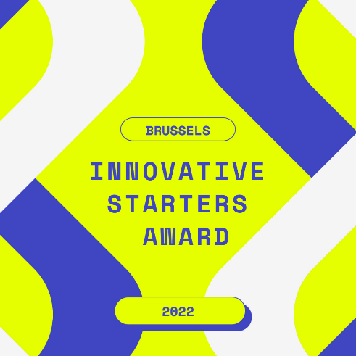

Linkedin

